­­

**Ex1:**

**­**

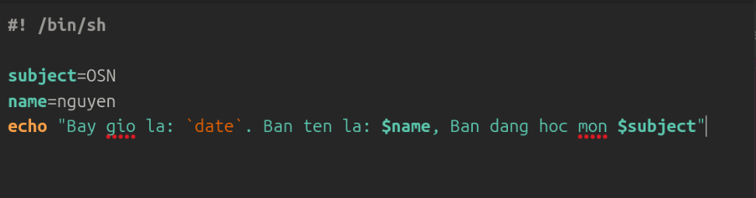

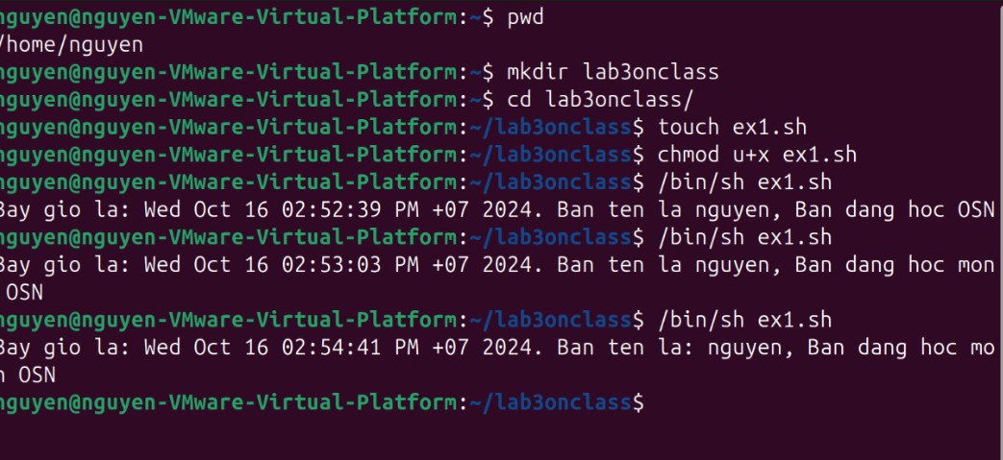

**Ex2:** Write a program let user to enter his name, age. Then, display his entered name and age.

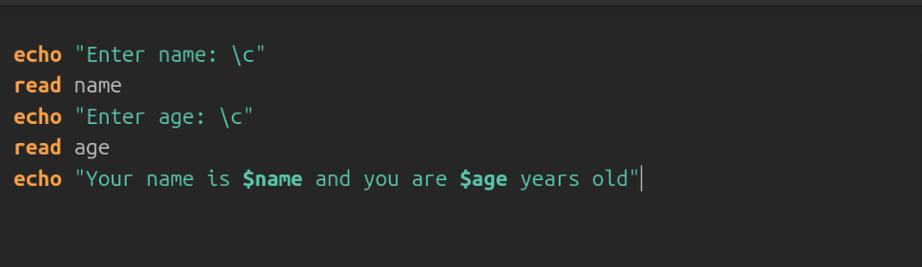

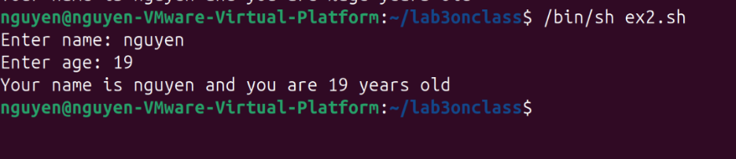

**Ex3:** Enter an integer n

If n > 0 display **“Positive number”**

If n < 0 display **“Negative number”**

If n == 0 display **“Zero”**

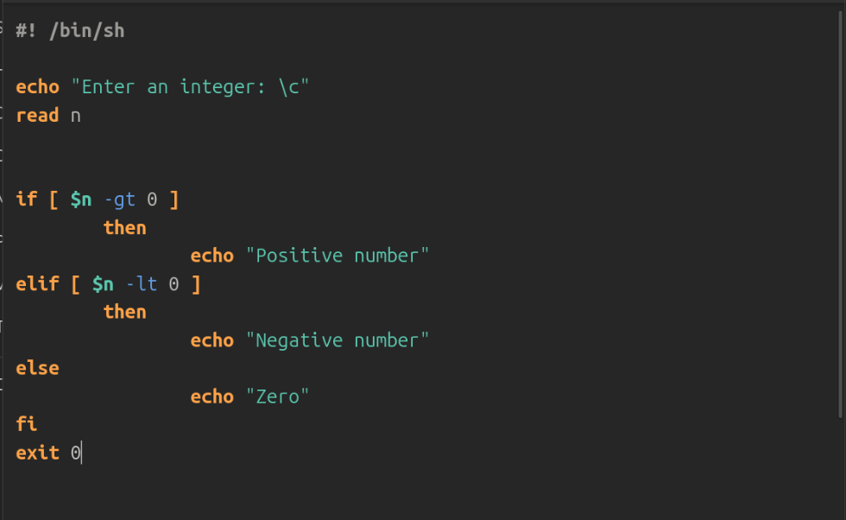

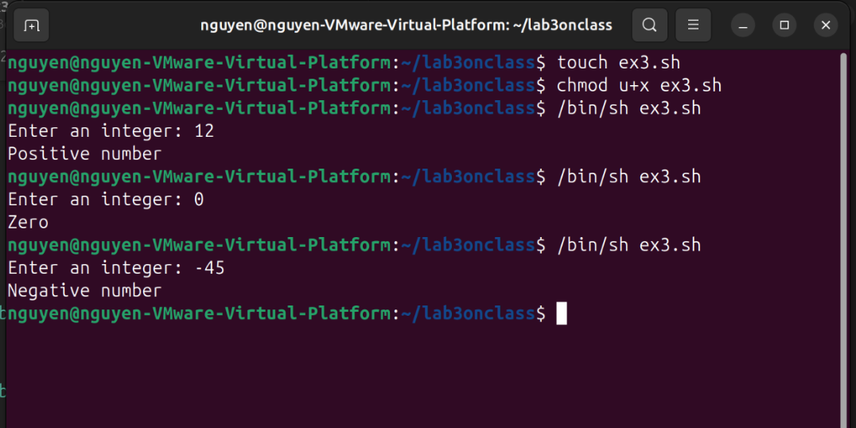

**Ex4:** Code a program named **doCal.sh** so you can pass 3 parameters to this program. The program will calculate the result as following and show it in the screen.

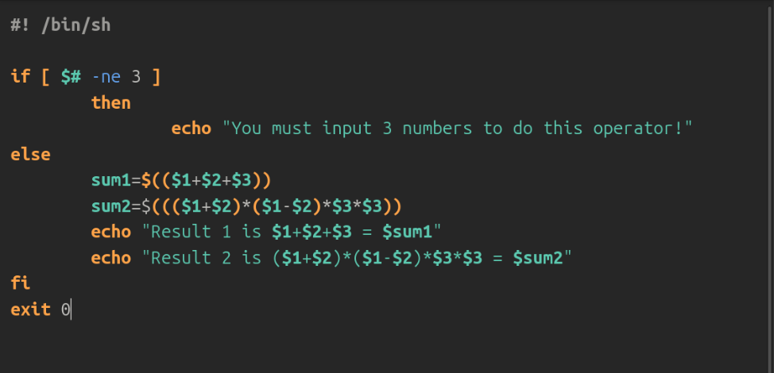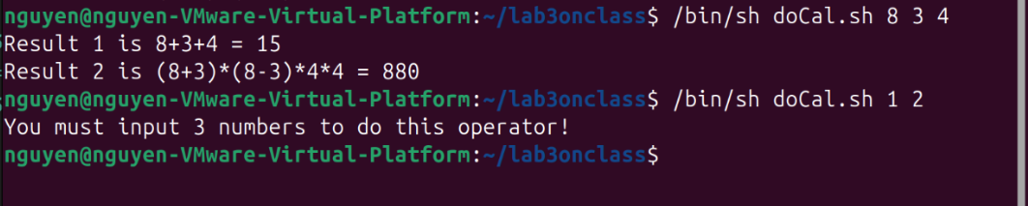

**­­­­­**

**Ex5:**

Write a shell script to find the sum, the average and the product of the four integers entered.

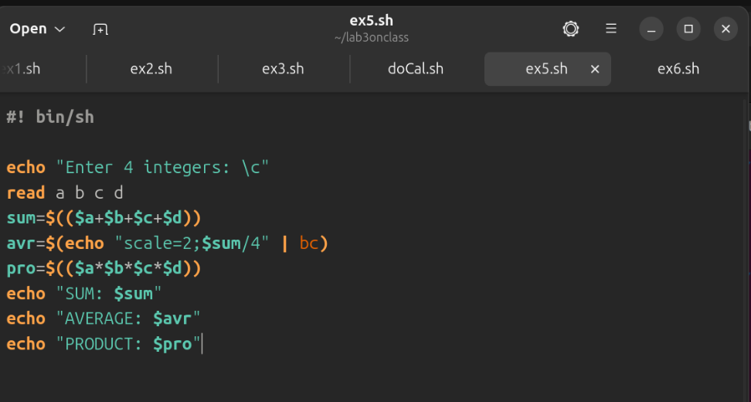

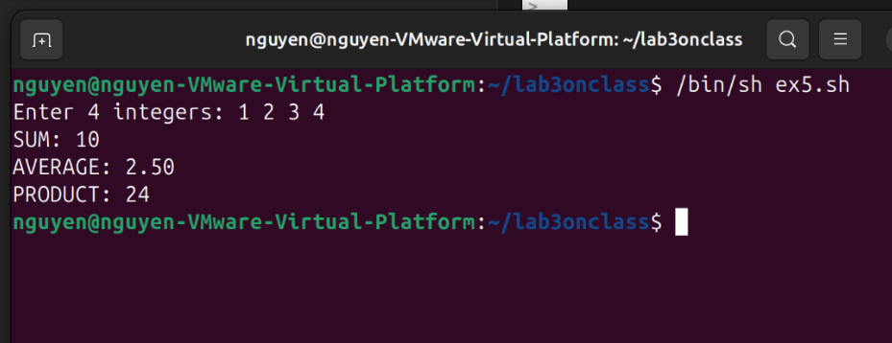

**Ex6:**

Write a shell script to ask user that he want to know about month or year? Then display the result in number.



